Lecture 8: The mass platform and the road to Peterloo
Structure of the lecture:
- Object of the week – the Middleton banner
- Situation post-war
- Radicalism in text
- Radicalism in action
- Peterloo

Radicalism in text
William Cobbett, Political Register – published as unstamped 2p sheets from 1816-17
T. J. Wooler, The Black Dwarf (1817)
William Hone, The Political House that Jack Built (1819-20)
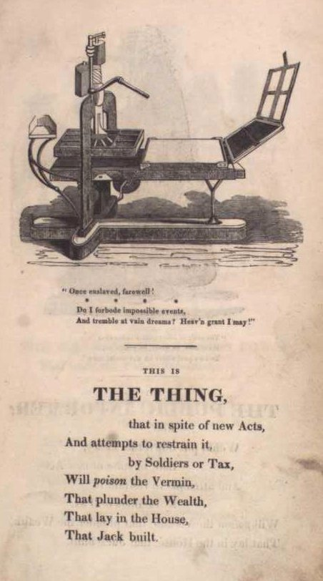

Radicalism in action
Hampden clubs
Spa Fields and the mass platform 1816-17
Petitions - by March 1817, the number of petitions to parliament for reform rose to 514, with an estimated 1 ½ million signatures. Of these, 468 were printed petitions distributed by Cartwright.
Blanketeers
Peterloo
Samuel Bamford, Passages in the Life of a Radical (1849), vol II, chapter 25.
http://gerald-massey.org.uk/bamford/c_radical_%288%29.htm#XXV.
By eight o'clock on the morning of Monday, the 16th of August, 1819, the whole town of Middleton might be said to be on the alert: some to go to the meeting, and others to see the procession, the like of which, for such a purpose, had never before taken place in that neighbourhood.
First were selected twelve of the most comely and decent looking youths, who were placed in two rows of six each, with each a branch of laurel held presented in his hand, as a token of amity and peace; then followed the men of several districts in fives; then the band of music, an excellent one; then the colours: a blue one of silk, with inscriptions in golden letters, "Unity and Strength," "Liberty and Fraternity"; a green one of silk, with golden letters, "Parliaments Annual," "Suffrage Universal"; and betwixt them, on a staff, a handsome cap of crimson velvet with a tuft of laurel, and the cap tastefully braided, with the word "Libertas" in front. Next were placed the remainder of the men of the districts in fives….

"The soldiers are here," I said; "we must go back and see what this means." "Oh," some one made reply, "they are only come to be ready if there should be any disturbance in the meeting." "Well, let us go back," I said, and we forced our way towards the colours.
On the cavalry drawing up they were received with a shout of good-will, as I understood it. They shouted again, waving their sabres over their heads; and then, slackening rein, and striking spur into their steeds, they dashed forward and began cutting the people.
"Stand fast," I said, "they are riding upon us; stand fast." And there was a general cry in our quarter of "Stand fast." The cavalry were in confusion: they evidently could not, with all the weight of man and horse, penetrate that compact mass of human beings; and their sabres were plied to hew a way through naked held-up hands and defenceless heads; and then chopped limbs and wound-gaping skulls were seen; and groans and cries were mingled with the din of that horrid confusion. "Ah! ah!" "for shame! for shame!" was shouted. Then, "Break! break! they are killing them in front, and they cannot get away;" and there was a general cry of "break! break." For a moment the crowd held back as in a pause; then was a rush, heavy and resistless as a headlong sea, and a sound like low thunder, with screams, prayers, and imprecations from the crowdmoiled and sabre-doomed who could not escape.
By this time Hunt and his companions had disappeared from the hustings, and some of the yeomanry, perhaps less sanguinarily disposed than others, were busied in cutting down the flag-staves and demolishing the flags at the hustings.
On the breaking of the crowd the yeomanry wheeled, and, dashing whenever there was an opening, they followed, pressing and wounding. Many females appeared as the crowd opened; and striplings or mere youths also were found. Their cries were piteous and heart-rending; and would, one might have supposed, have disarmed any human resentment: but here their appeals were in vain. Women, white-vested maids, and tender youths, were indiscriminately sabred or trampled; and we have reason for believing that few were the instances in which that forbearance was vouchsafed which they so earnestly implored.

Impact of Peterloo
Queen Caroline affair

Timeline:
1815 –
Corn Laws
1815-16 –
formation of Hampden clubs across the north and midlands.
1816 –
15 November – first Spa Fields mass meeting attended by 20,000
2 December – second Spa Fields meeting dispersed by the authorities.
1817 –
23 January – gathering of Hampden Club delegates in London
28 January – window of the Prince Regent’s coach smashed as he travelled to parliament. Government response was to suspend habeas corpus and pass bills restricting public assembly.
30 January – T. J. Wooler starts the Black Dwarf
Grenvillites secede from the Opposition after defending government repression
10 March - ‘March of the Blanketeers’ from Manchester
June – Pentridge Rising, Derbyshire
1818 -
general election - ministry = 280 supporters in the Commons. Opposition had 175 MPs and 203 MPs were regarded as ‘uncommitted’.
1819 -
12 July – Birmingham meeting of 25,000
21 July – Smithfield meeting
30 July – royal proclamation issued against seditious libels, drilling and unlawful assembly.
16 August – ‘Peterloo massacre’ in Manchester
November-December - ‘Six Acts’ passed against seditious meetings and publications
1819-20 –
William Hone, The Political House that Jack Built
1820 –
Queen Caroline affair
1822 –
sliding scale of Corn Laws introduced

Further Reading:
William Hone e-texts: http://www.uab.edu/english/hone/etexts/etexts.htm
http://www.bl.uk/onlinegallery/takingliberties/staritems/26blackdwarf.html
M.J. Turner, The Age of Unease (2000), chapter 6.
John Belchem, 'Henry Hunt and the evolution of the mass platform', English Historical Review, 93 (1978), 739-73

Robert Poole, 'The March to Peterloo: Politics and Festivity in Late Georgian England', Past & Present, 192 (2006), 109-53

Michael Laccohee Bush, 'The Women at Peterloo: The Impact of Female Reform on the Manchester Meeting of 16 August 1819', History, 89:294 (2004), 209-232

