Lecture 9: Loyalism

Structure of the lecture:
- return to the debate about Pitt’s ‘reign of terror’ in the 1790s
- vulgar conservatism
- ‘Liberal Toryism’ and the 1820s
- ‘Ultra’ Toryism

Object of the week: Cheap repository tract: ‘The Riot, or half a loaf is better than no Bread’ (1795) [British Museum]
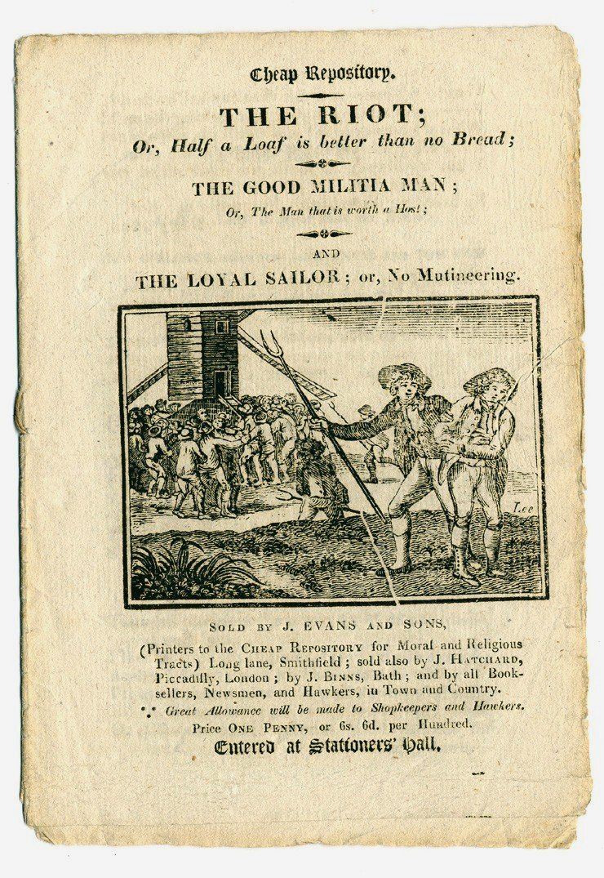

Definition of loyalism…………………………………………………………………….

1790s:
Loyalist legislation: a ‘reign of terror’? Pitt and the Two Acts

Loyalism outside parliament:
- Burke’s Reflections on the French Revolution 1791
- Cheap Repository Tracts
- John Reeves’s association for preserving…………………………..against………………………………………
- ‘vulgar conservatism’…………………………………………………………………

‘Both in forming the Association movement and in subsequently developing a literature designed for the lower orders, loyalists breached the traditional boundaries of the political nation and thereby advanced a process of mass participation which they had come into existence to prevent’.

Philp, M., 'Vulgar Conservatism, 1792-3,’ English Historical Review, 110 (1995), 45.

- ‘Church and King’ riots and Paine-effigy burnings

On Monday the 17th inst. [of December] the effigy of Tom Paine was burnt in Dover, amidst a greater number of people than ever was remembered to assemble there at any one time. He was drawn through the town in a cart; in his hands were The Rights of Man and a pair of old stays. Preceding the procession were transparencies in abundance, adapted to the occasion; the clergymen who attended repeatedly directed him to reflect on the misery he was likely to bring on the inhabitants of this happy isle, had not Providence, which generally checks the projects of malicious minds, interfered; and about seven o’clock in the evening, he arrived at the place of execution, amidst the hisses of persons innumerable, when the sentence which had been passed on him was at the request of the populace read by the executioner . . .

It is remarkable, the first object that caught the flames was The Rights of Man, and the last visible remains, the Stays. The whole time the bands were playing and the populace singing God Save the King. The torches, flambeaux and fireworks were more than could be expressed. The multitude then adjourned in procession to King Street where the malefactor’s confession was read to between two and three thousand persons.

Kentish Gazette, 28 Dec. 1792, in F. O’Gorman, ‘The Paine Burnings of 1792-3’, Past and Present, 193 (2006), 124.

1810s:

Six Acts of 1819

1820s

‘Ultra Toryism’

Eldon, York, Cumberland, Mansfield, Newcastle

Key dates:

1780 – Gordon Riots
1791 – Edmund Burke, Reflections on the French Revolution
1791 – July – Church and King mob attack Joseph Priestley’s house and chapel in Birmingham
1792 – May – Royal proclamation against seditious publications and writings
1792 – November - John Reeves founded the Association for Preserving Liberty and Property against Republicans and Levellers.
1792 – December – Church and King mob attack Manchester Herald offices
1792 – December and 1 January 1793 – burnings of effigies of Thomas Paine across the country
1793 – February – John Frost, a founder of the LCS, imprisoned for sedition
1793 – Scottish radicals Thomas Muir and Thomas Palmer sentenced to transportation
1793 – September – attack on Sheffield newspaper editor John Gales’s houses
1794 – 12 May- leaders of the London radical societies arrested and papers seized
1794 – 18 May – habeas corpus suspended
1794 – Manchester and Sheffield radicals arrested; London radicals Thomas Hardy and John Thelwall and John Horne Tooke indicted for treason but acquitted.
1795 - ‘Two Acts’ against seditious writings and meetings – Seditious meetings act and Treasonable Practices Act.
1799 – LCS and United societies banned
1799-1800 – Combination Acts prohibit trade unions combining to raise wages
1812-27 ministry of Lord Liverpool
1817 – suspension of habeas corpus and bills restricting public assembly
1819 – November-December - ‘Six Acts’ against drilling, assemblies, arming, seditious writings
1820 – January – George IV succeeds to the throne
1820 – March – Henry Hunt and other ‘Peterloo’ radicals tried – found guilt of unlawful assembly and imprisoned. Sir Francis Burdett fined £2000.
1825 – repeal of the Combination Acts
1827 – ministries of Canning, and Wellington
1828 – repeal of Test and Corporation Acts
1829 – Catholic Emancipation Act
1830 – June – death of George IV, succession of William IV
1830 – 2 November – Wellington speaks in the House of Lords against parliamentary reform
November - Grey’s coalition ministry formed after ministry resigned

Further reading:

Philp, M., 'Vulgar Conservatism, 1792-3,’ English Historical Review, 110 (1995), 42-69
Colley, Linda, ‘The Apotheosis of George III: Loyalty, Royalty and the British Nation, 1760-1820,’ Past & Present, 102 (1984)
Schofield, T. P., 'Conservative political thought in Britain in response to the French Revolution', Historical Journal, 29:3 (1986), 601-22
Harling, Philip, 'The law of libel and the limits of repression, 1790-1832', Historical Journal, 44:1 (2001), 107-34
C. Emsley, `Repression, ``terror '' and the rule of law during the decade of the French Revolution', English Historical Review, 100 (1985),
C. Emsley, `An aspect of Pitt's``terror '': prosecutions for sedition during the 1790s ', Social History, 6 (1981)

