Postgraduate history training session 6: How to guide
Geo-referencing and warping a historical map, and
Adding simple data to a digitized map

1. Geo-referencing and warping a historical map

geo-reference = making an ordinary image file into an image layer [=raster] that has geographical co-ordinates as part of the file
warping = reshaping the map to be geographically accurate [e.g. old maps, especially prior to OS, are not entirely accurate].

Step 1. Get a high-resolution version of your historical map (from a map library, Edina Historic Digimap [available through Voyager learning resources, registration required], or scan your own.
Step 2. Upload the image file to a map warper site [e.g. http://mapwarper.net/ or http://maps.nypl.org/warper/] [registration required]
Step 3. Click on ‘rectify’. Your old map will be on the left, with a current map on the right. You may need to zoom in to find the right place.
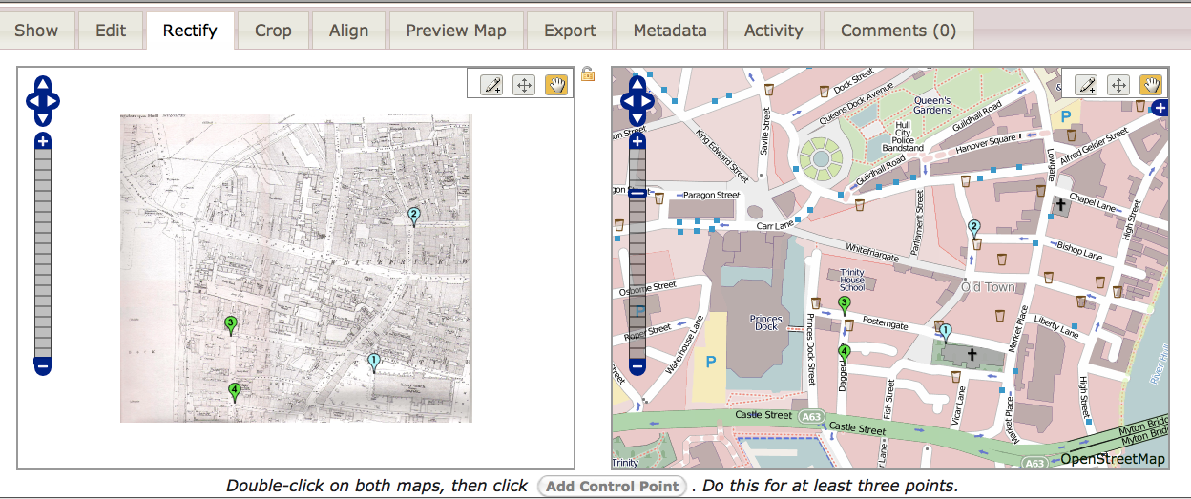
Click on the pencil icon and then click on a place on the historical map (e.g. street corner, corner of a church) and the corresponding place on the modern map. Click ‘add control point’. Do this at for at least 4 points.
Step 4. Click on ‘control points’. You should see a list of co-ordinates and the margin of error. If any of your points has an error of over 10, delete it and add another.
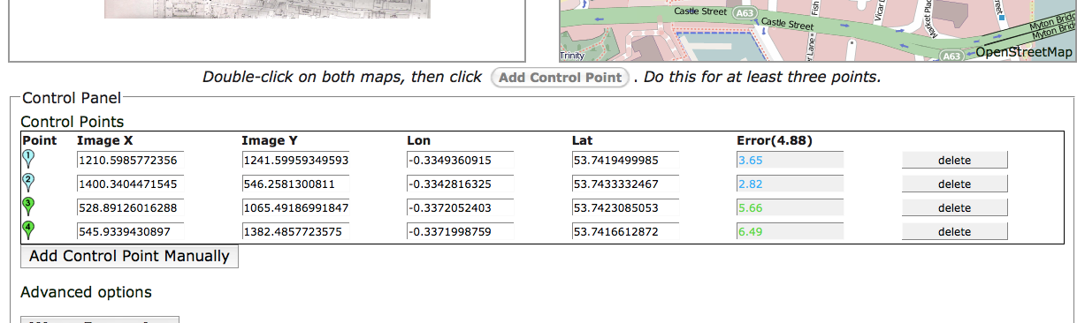
When you’re happy with the points, click on ‘warp image’.
Step 5. Click on ‘preview map’ to see your map overlaid on the modern map. You can adjust the transparency if you like.
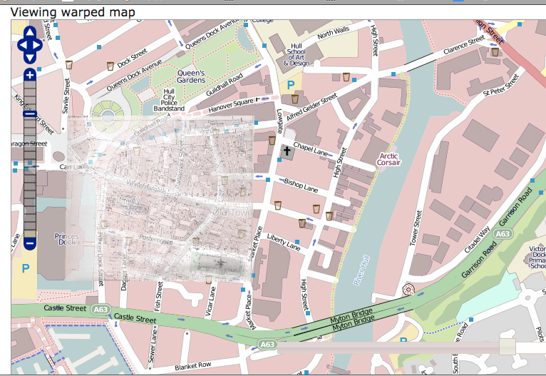
Step 6. Click on ‘export’. You can then download the file in different formats. Choose ‘download kml file’. You can use this in google earth or ArcGISviewer. Click on ‘view in google maps’ to view in google maps.
KML = file that includes both the image and the geographical co-ordinates and any other data you layer on the image.
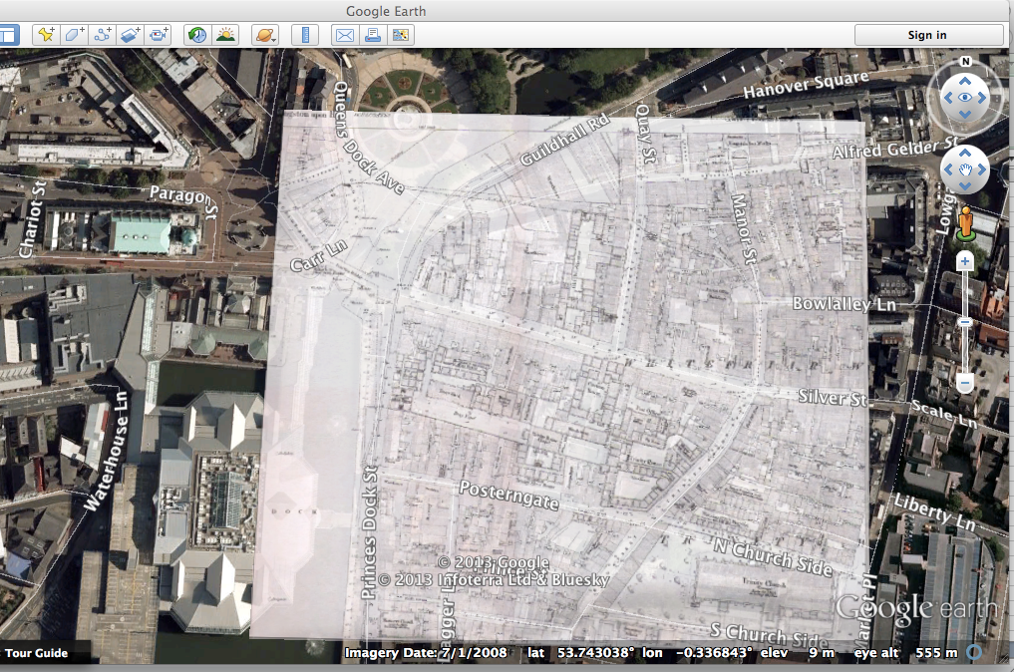

COUNTY, CENSUS AND PARISH BOUNDARY MAPS AND OLD OS MAPS

You can download old os maps from Edina Historic Digimap - This service is available via Voyager/learning resources & through Athens off campus.
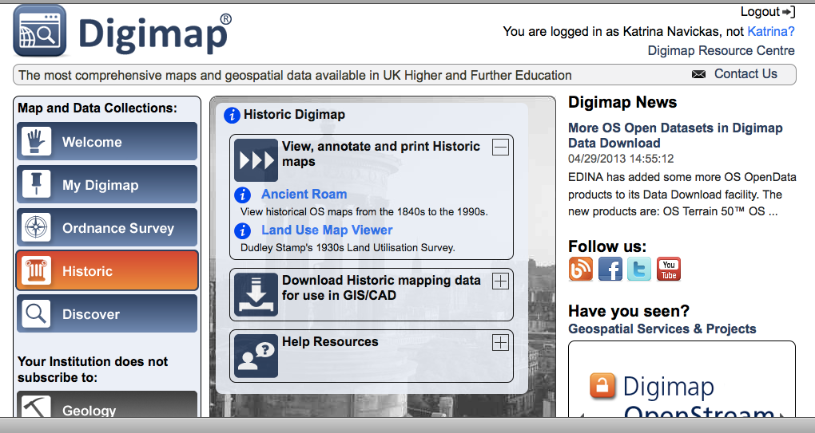

If you want county or parish or census boundary shapefiles, then you can download them from Edina Share Geodigimap.
Go to ‘discover’>’share Geodigimap’ and then look for the dataset you want.
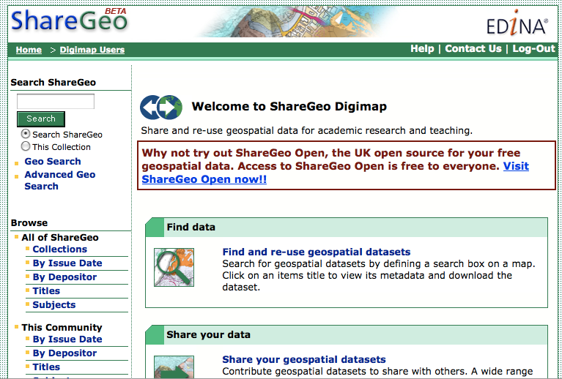

MAPPING YOUR DATA

Step 1. Set up a new excel file with a column for each section of data, e.g. name, street, place, date, source.
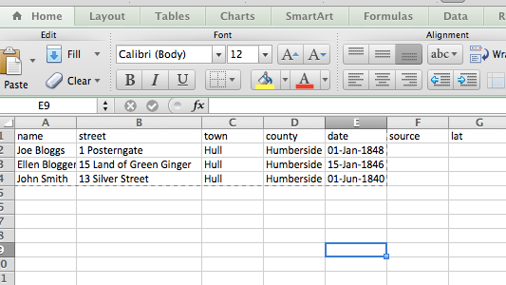

Step 2. Save it as a ‘csv’ file [csv = comma separated values].

To geo-code the points and map there are four options:
1) do it yourself in google earth
2) do it yourself in google maps (you can also draw lines and polygons easily by hand)
3. use batch geo or similar automatic geo-coding site
4. use google fusion tables

Option 1. do it yourself,
Find the addresses using your map on google earth, then writing down the latitude and longitude co-ordinates – e.g.
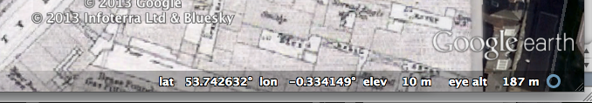

Option 2. Use google maps.
You need a google account.
Go to https://maps.google.com/
Click on ‘create map’ and then add your points (or lines or shapes) manually by clicking on the pinpoint or line in the left hand corner. 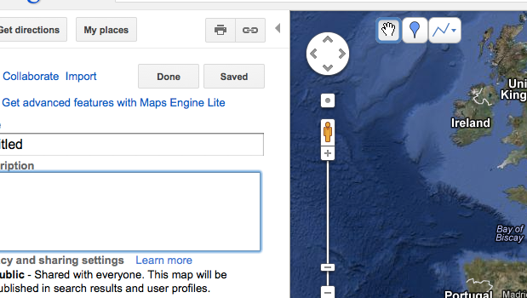
Once saved, wait a bit, click on edit again, and you can then export the file as kml to google earth or similar (click on ‘kml’ under the title of the map on the left hand side).

Option 3. www.BatchGeo.com

Use batchgeo or similar to find the locations for you [note BatchGeo is not always accurate, so you may have to move the points manually on their map].
Copy the excel sheet with headings, delete the box of sample data on the website, and then paste your data into the box and click ‘map now’ –
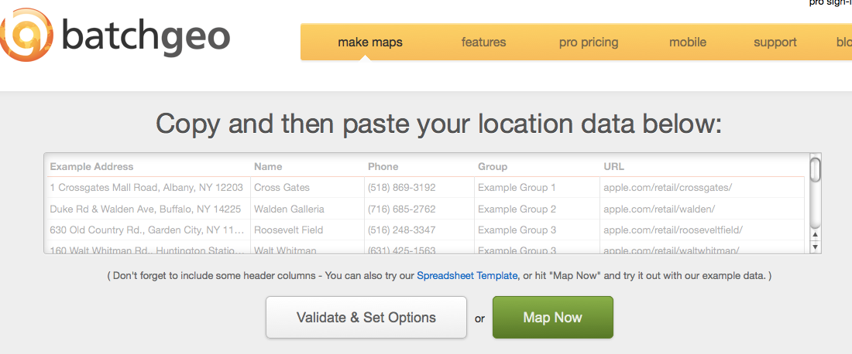
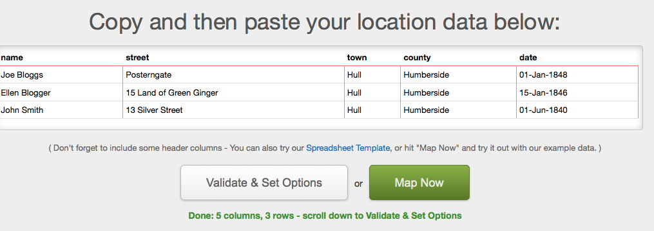
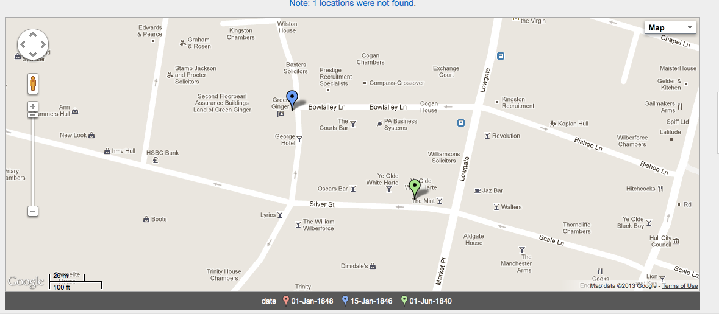
Click on ‘save and continue’ and you can then embed it into a website etc.
You can also download the kml file and then open it in google earth on top of your historic map.

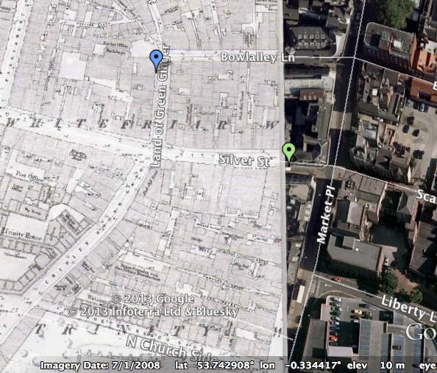

Option 4. Google Fusion Tables
For this you need a google account.
Step 1. Go to google fusion tables [go to google drive and click on ‘apps’ or go to https://www.google.com/fusiontables/DataSource?dsrcid=implicit&redirectPath=data&usp=apps_start&hl=en]
Step 2. Upload the excel csv file to your drive account as a fusion table. Make sure your file includes columns for longitude and latitude.
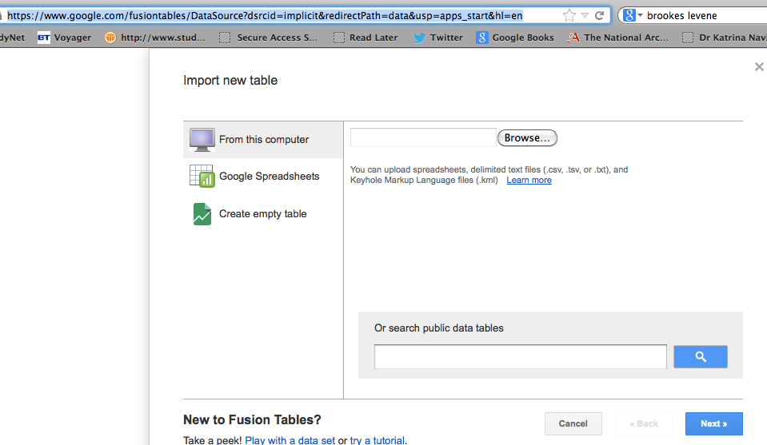
Check the right column names are in the table.
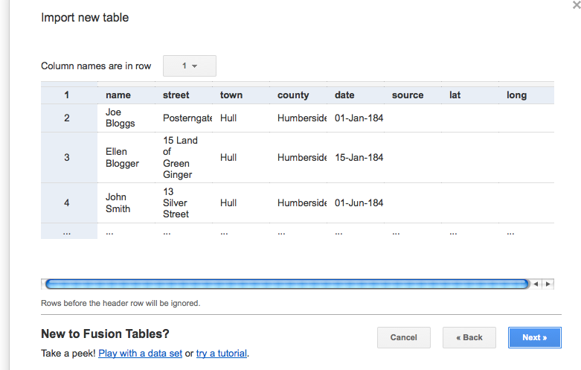

Click on next and then finish.
Step 3. Click on ‘edit’ and ‘change columns’.
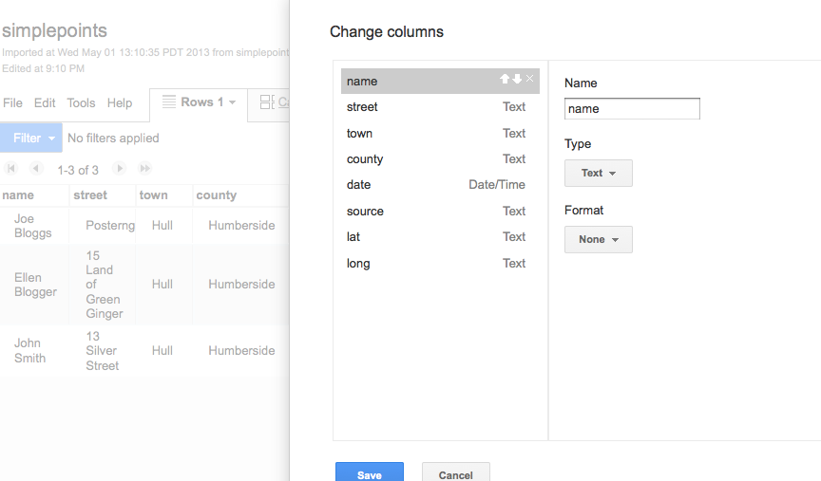
a) If you don’t have the lat and long, then click ‘street’ and change type to ‘location’ and do the same for ‘town’ etc. If you already have the lat and long, then leave these as ‘text’.
b) Click ‘lat’ or ‘latitude’ and then change type to ‘location’ and check ‘two column location’ and make sure that latitude = lat and longitude = long.
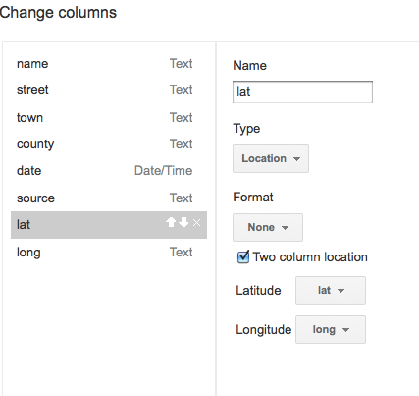

Click on save and then click on the + tab and ‘add map’.

Step 4: If you have already added latitude and longitude to the table, then it should geo-code the addresses for you.
If you have not added latitude and longitude, click on ‘file’ ‘geocode’ and select the column you want to geo-code (e.g. street) and also click on ‘location hint’ and add the place.
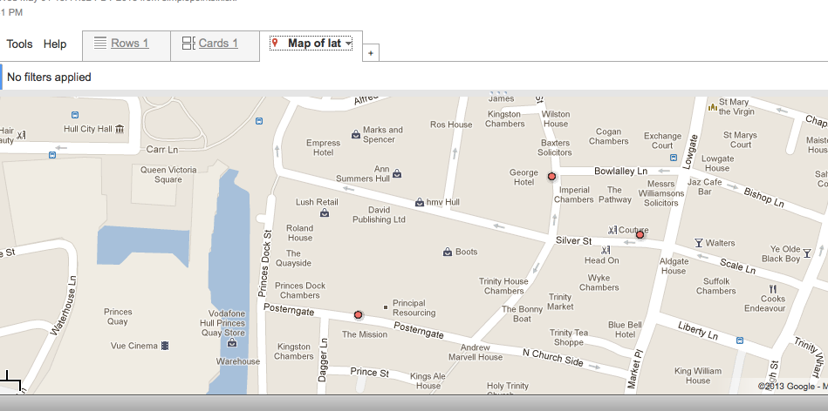
Step 5 (optional) You can change the appearance of the dots by adding another column, ‘colour’, for example, for type of place, and then choose different colours for different types – e.g. ‘large_green’ for a pub, ‘large_blue’ for a private house, ‘large_yellow for a town hall’. Then, while in map view, click on ‘tools’> ‘change map styles’ > ‘Column’ and check ‘use icon specified in column’ and select the correct column.

Step 6. You can then download the table as a kml file and open it on your google earth layer. Click on ‘file’>’download’ and check ‘kml’. Either save it or open it in google earth.

