Workshop 3: the Gordon Riots of 1780

Structure:
1. discussion of Tim Hitchcock’s lecture and Voices from the Old Bailey programme
2. George Rude’s article on the Gordon Riots compared with Nicholas Rogers’ interpretation
3. primary sources: Old Bailey Online trials
4. primary sources: James Gillray cartoon and Fielding and Walker painting.

Main events:
1778 Catholic Relief Act passed in England.

Friday 2 June 1780 – 60,000 gathered at St. George’s Fields, Southwark to present a petition to parliament calling for repeal of the relief act
Unrest following Lord George Gordon’s presentation of the petition.
One section of the crowd moved off to the private chapel of the Sardinian ambassador in Duke St, Lincoln’s Inn Fields; another to the chapel attached to the Bavarian Embassy in Warwick St, St. James’s.

Saturday 3 June 1780 – crowds gathered in Ropemakers’ Alley, Moorfields.
Sunday 4-Monday 5 June – attacks on Catholic chapels and houses.
Tuesday 6 June – parliament reassembled, met by crowds, adjourned.
Riot Act read at 5 o’clock. Crowds moved to St. Martin’s Street, Leicester Fields to attack the magistrate’s house, and then to Newgate prison to release prisoners taken on 2 June. Another party destroyed the Police Office of Sir John Fielding. Old Bailey attacked and on fire. Clerkenwell bridewell and prison attacked.
Lord Mansfield’s house in Bloomsbury Square attacked. Military fired for the first time, killing several.

‘Black Wednesday’ 7 June – riots reached climax. Shops and offices attacked in Westminster, City, and Middlesex.
6pm – Catholic Thomas Langdale’s gin distillery in Holborn fired. Fleet Prison attacked. King’s Bench Prison set on fire, as well as New Gaol, Southwark, and Surrey House of Correction. Blackfriars Bridge taken. Attempt at capturing the Bank of England, but London Military Association defended it.

Thursday 8 June – riots continued in Southwark and Bermondsey, St. George’s Fields and Fleet Street.
Friday 9th- Lord Gordon arrested and escorted to the Tower.

Of more than 450 people arrested, 160 appeared for trial at the Old Bailey, and at Southwark and Guildford. 62 sentenced to death (25 were eventually hanged).
Gordon tried for treason before the King’s Bench in February 1781, but was acquitted.
210 people killed outright; 75 died in hospital, and 173 treated for wounds.

Set reading:
G. Rudé, ‘The Gordon Riots: A Study of the Rioters and their Victims,’ Transactions of the Royal Historical Society, 5th ser, 6 (1956), AND
Nicholas Rogers, Crowds, Culture and Politics in Georgian Britain, chapter on the Gordon Riots.
In groups, summarise in a paragraph, Rude, Rogers and Hitchcock's explanations of:
1. the causes of the riots;
2. the type of people involved;
3. how the riots developed over time
4. the response of the authorities.

Old Bailey trials:
Find two or three trials of Gordon Rioters in Old Bailey Online.
- How does the prosecution describe them?
- How do they defend themselves?
- Note down any interesting or significant phrases.
- How might you use this evidence to understand the causes, spread, and organisation of the Gordon Riots?

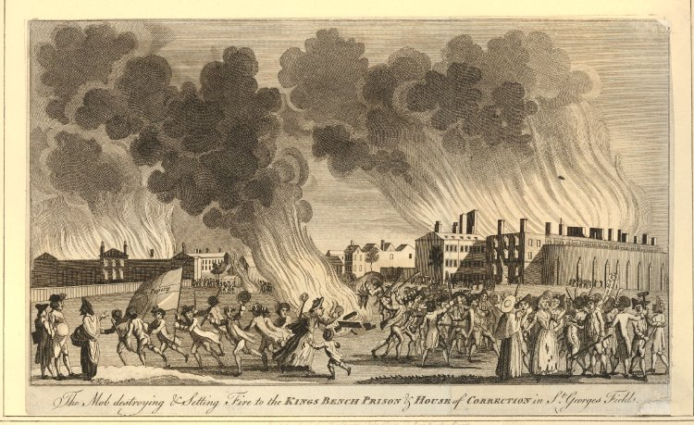
‘The Mob destroying & Setting Fire to the Kings Bench Prison & House of Correction in St Georges Fields’, 1780-5

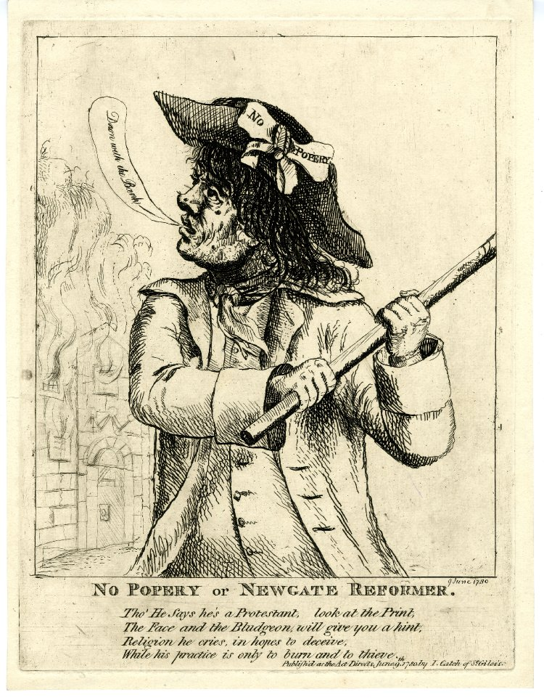
‘No Popery or Newgate Reformer’, 1780

George Rude, ‘The Gordon Riots: a Study of the Rioters and their Victims’, Transactions of the Royal Historical Society, 6 (1956), 96-99.

