Week 1: the long eighteenth century: an introduction, as seen through William Hogarth’s eyes

Key themes of the eighteenth century:

1. Class:………………………………………………………………………..
2. Sociability, a ‘polite and commercial people’………………………
3. Enlightenment and empire………………………………………………..
4. Liberty and corruption……………………………………………………..
5. Crime and the underworld…………………………………………………

William Hogarth (1697-1764) and his cultural significance

‘The Rake’s Progress’ (1734) – a moral allegory of social emulation and its dangers

Plate 1: ‘The Rake Taking Possession of his Estate’
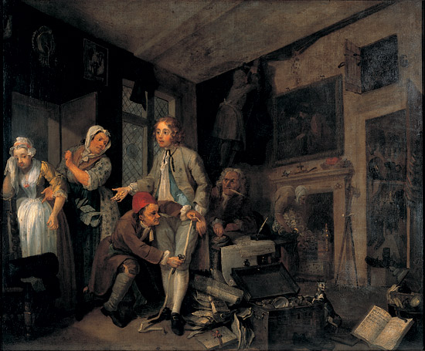

plate 6, ‘The Rake at the Gaming House’
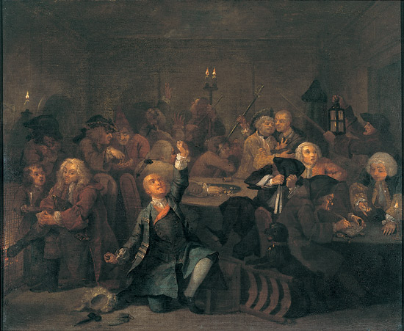

plate 8, ‘the Rake in Bedlam’
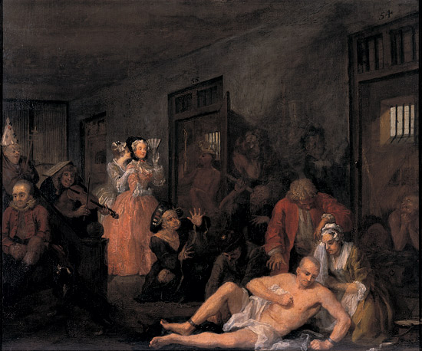

Key theme: According to Hogarth, the façade of a ‘polite and commercial people’ hid the reality of luxury and corruption in eighteenth-century society and politics.

Hogarth’s main objects of satire:
……………………………………………..

Seminar tasks:

Analyse the differences between the two plates, ‘Gin Lane’ and ‘Beer Street’ (1751).

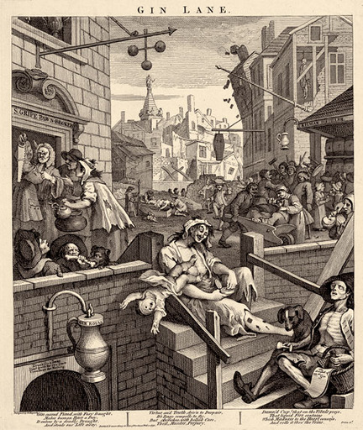
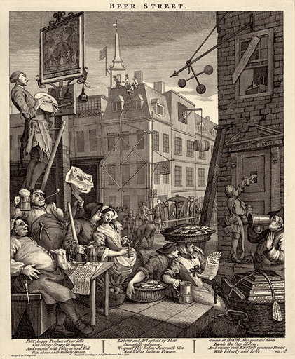

Historiography:
Older historiography…………………………………………………………………
Newer historians focus on………………………………………………………….

Frank O’Gorman, The Long Eighteenth Century, 1688-1832
Why do many historians term this period the ‘long eighteenth century’?
Highlight some of the key dates.

What was politics in the eighteenth century? How have historians understood politics?

John Brewer, The Pleasures of the Imagination
What was culture in the long eighteenth century?

